SQL

(DDL AND DML Commands)

Yazhini S

1)Creating Database

-> By using the **create database** keyword ,a new database id created.

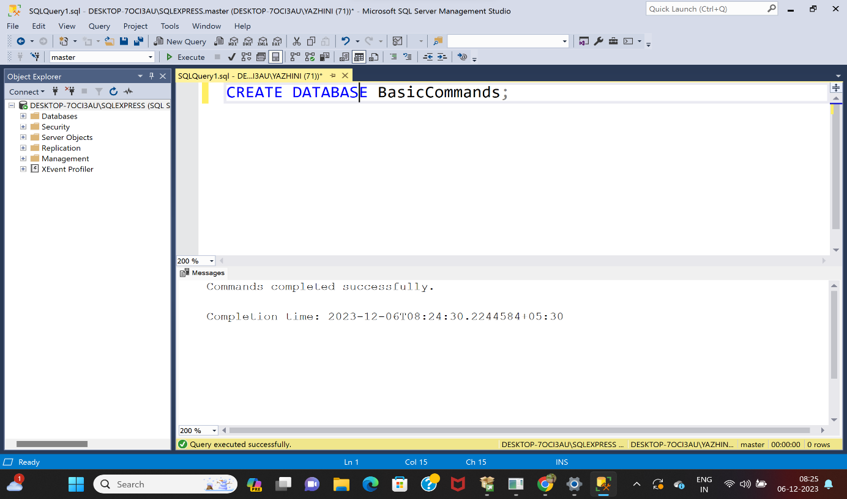

2)Creating Tables

->by using **create table** keyword , I created two tables in the of Employee and Employee1.

->There are 4 attributes used in Employee table:Name , lastname , age, id.

->There are 3 attriutes used in Employee1 table: Deparment, Salary, Joining_date.

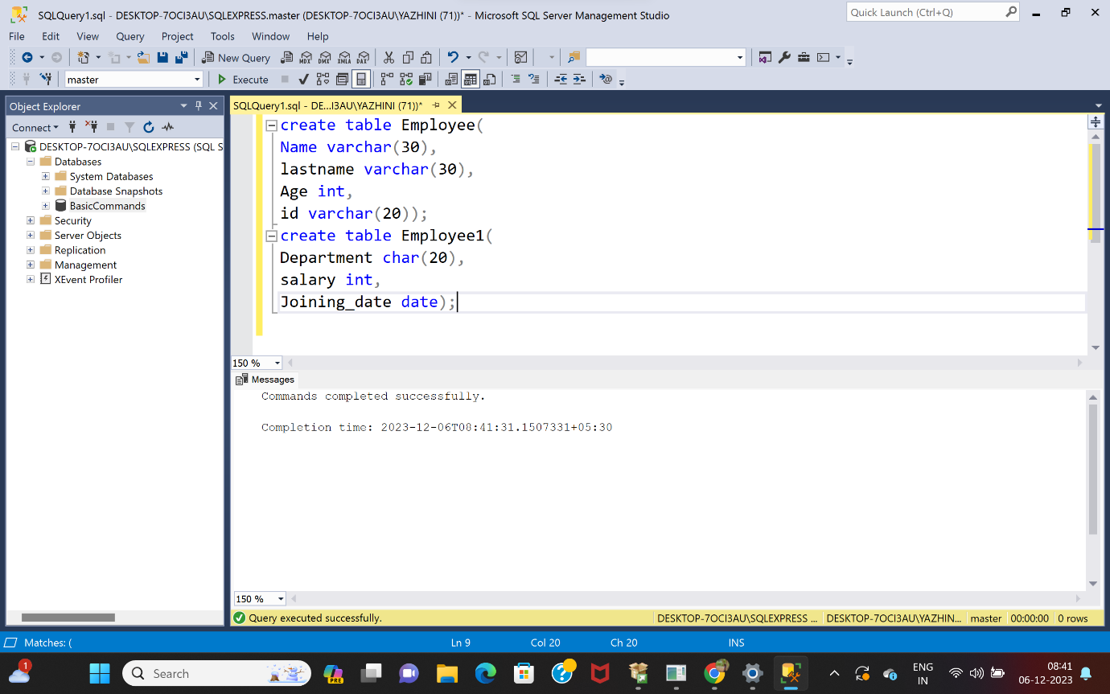

3)Inserting values

->Based on key-value,I added values to the column in the Employee table.

->The key value is entered for every pairs based on the attribute data type and data size.

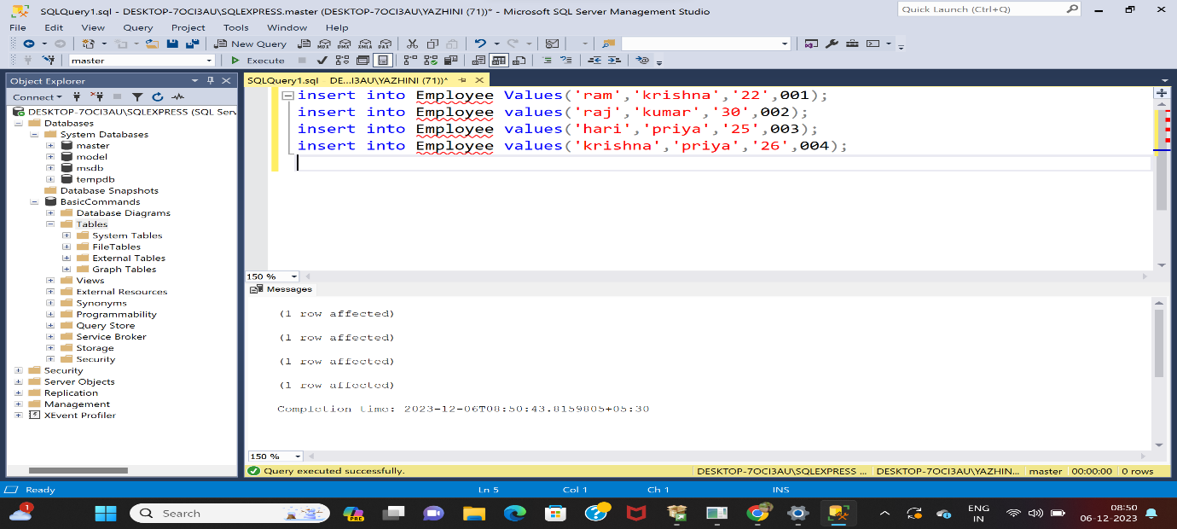

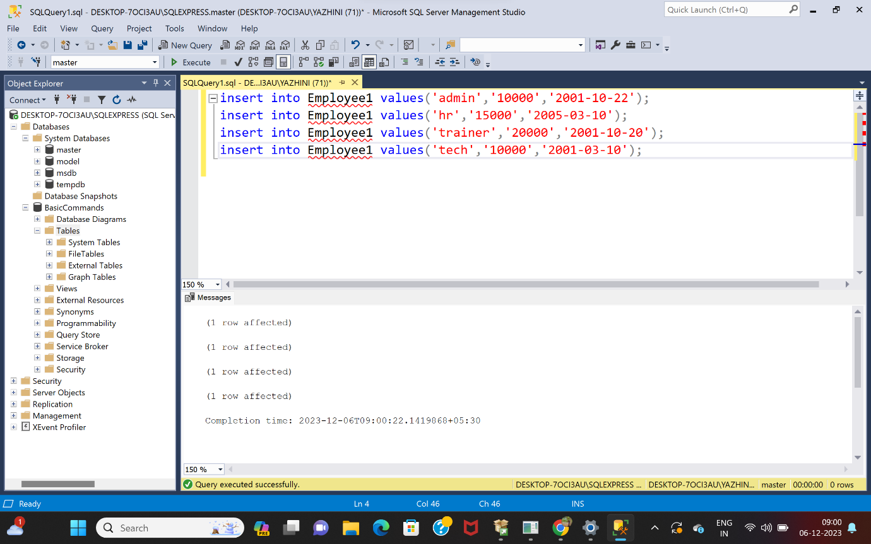

4) Select keyword

->To view the table with its attributes ,I used select keyword

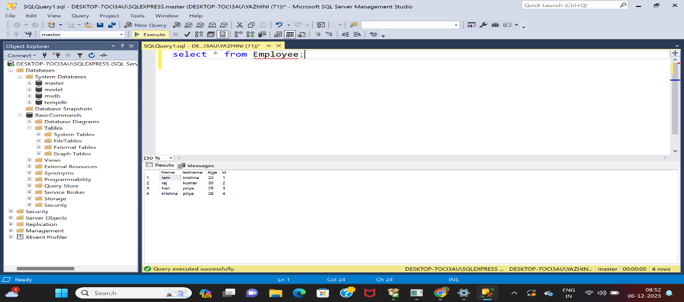

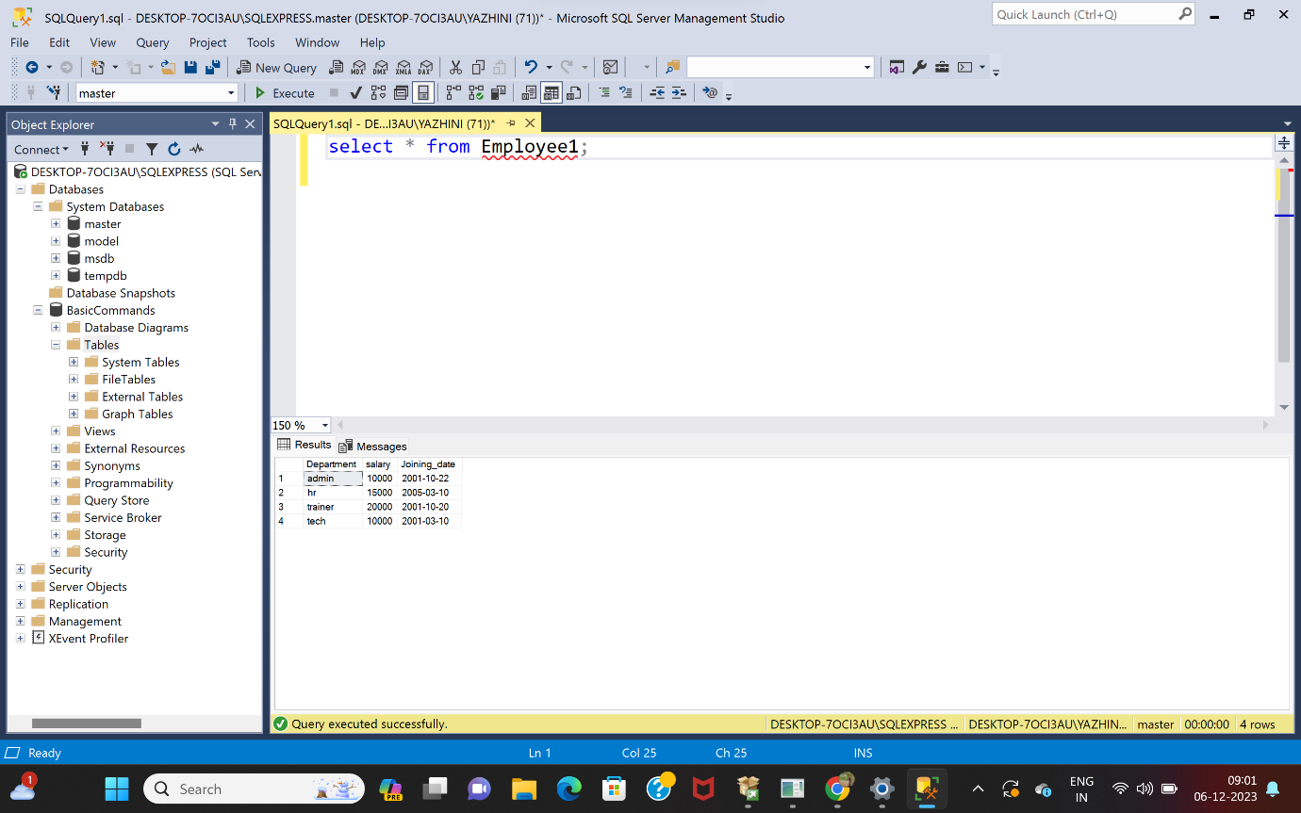

5)Alter table

-->I added a column named id in the Employee1 table by using **alter table** keyword.

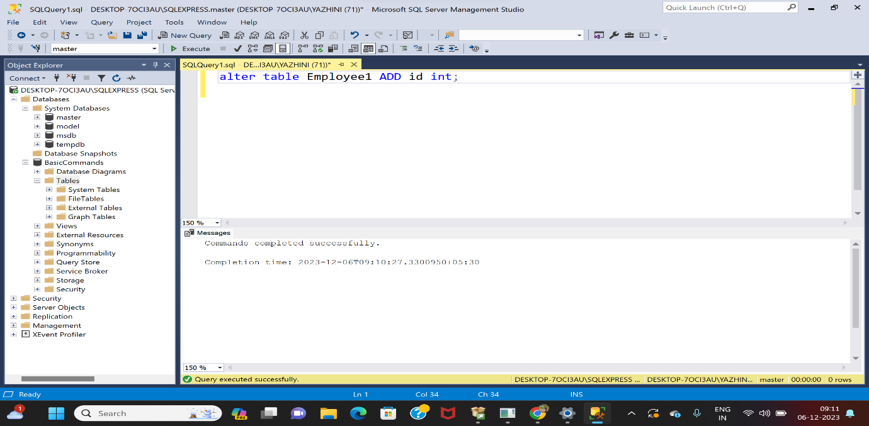

6)Selecting query with Where clause:

-> The condition is giving in the where clause.

->It checks whether there ia an id number 2 ,if the condition is true, the age is displayed.

->In the next condition, the salary is displayed.

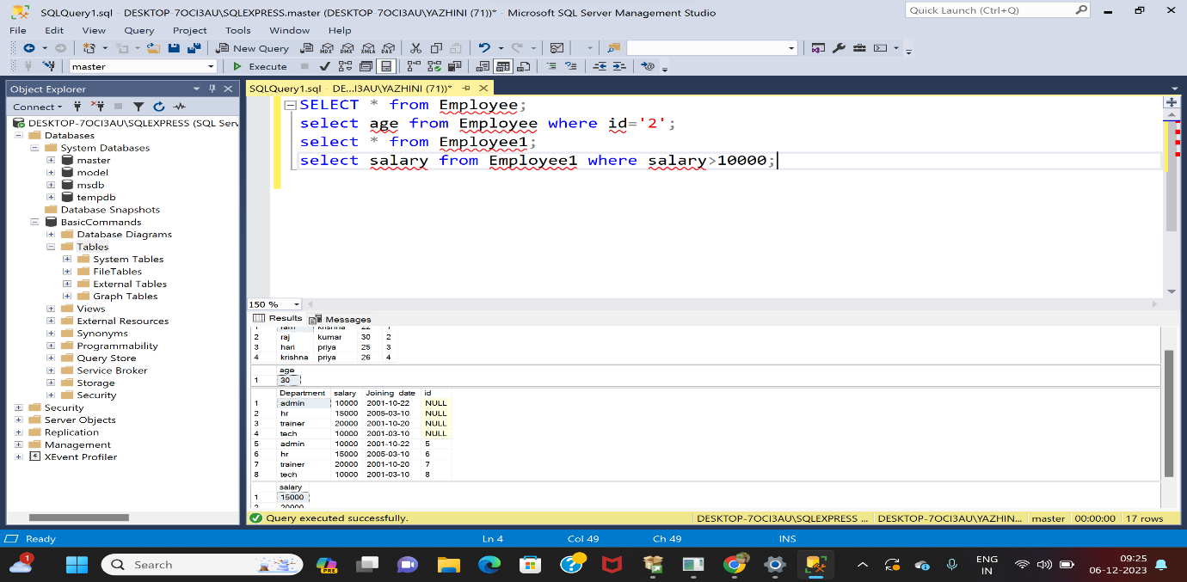

7)Delete

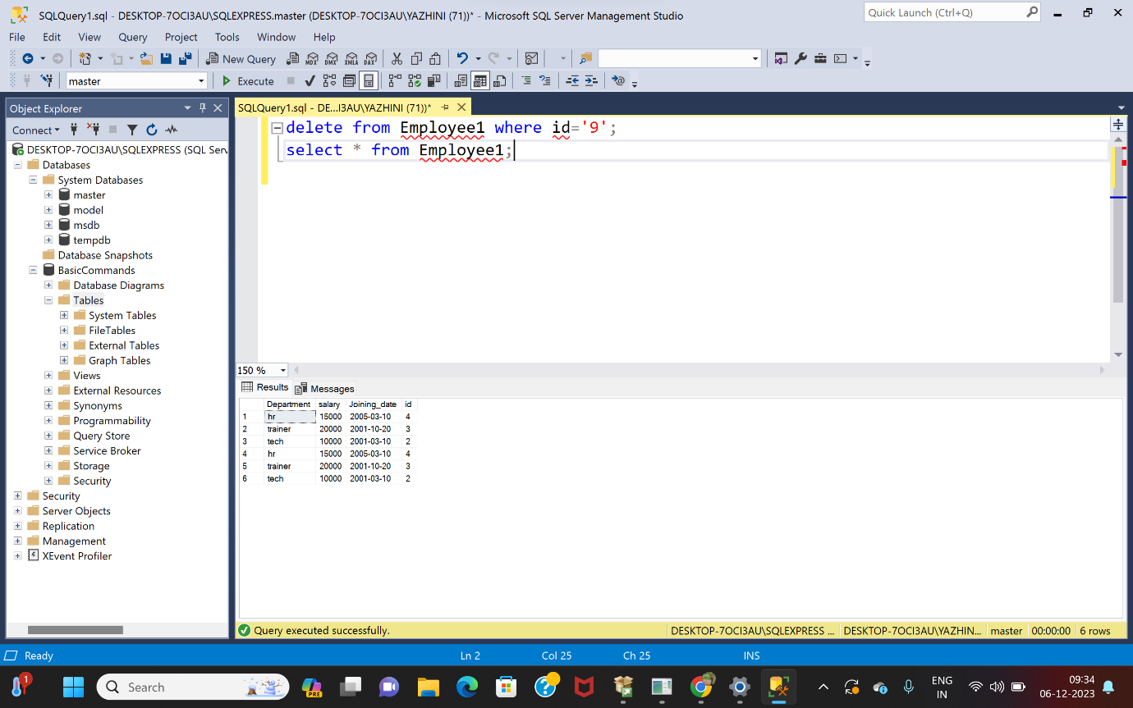

8)Drop

